FEA Lab Project Report



Static and Transient Structural Analysis of a Simple Polygon Structure

# Submitted By:

Wasif Mahmood

ME-1874

# Submitted To:

Sir Affan

Pakistan Navy Engineering College, Karachi

National University of Sciences and Technology, Islamabad, Pakistan

2026

Contents

FEA Lab Project Report 1

Submitted By: 1

Submitted To: 1

1. Introduction 3

2. Problem Definition 3

2.1. Geometry Selection 3

2.2. Material Properties 4

2.3. Boundary Conditions 4

2.4. Transient Analysis Loading Criteria 5

3. Geometry and Modelling 5

4. Meshing 6

5. Static Structural Simulation 6

5.1. Boundary Conditions 6

5.2. Results 7

5.3. Mesh Convergence (Static) 8

6. Transient Structural Simulation 8

6.1. Loading and Time Setup 8

6.2. Force Input Method 9

6.3. Results 9

7. Discussion 10

8. Conclusion 11

## Introduction

The primary aim of this engineering project is to perform detailed structural analyses—specifically Static Structural and Transient Structural (Transient Dynamics) simulations—on a base geometric component using the ANSYS finite element analysis (FEA) software suite.

All material properties, boundary conditions (BCs), loading conditions, and key simulation parameters are defined according to the user’s unique identifiers (roll number and date of birth), ensuring that the inputs remain personalized and traceable.

This technical report documents the full computational workflow and its outcomes. It covers the following major stages:

1. Geometric Modelling: Creation of the simplified model within the ANSYS pre-processor.
2. Material Definition: Assignment of material properties according to the project’s specified criteria.
3. Boundary Conditions and Loading: Detailed explanation of how constraints and mechanical loads were applied to the model.
4. Meshing Strategy: Description of the meshing approach, including element types, sizing, and refinement considerations.
5. Simulation Setup: Configuration of solver settings for both Static Structural and Transient Dynamics analyses.
6. Mesh Convergence Study: Verification that the solution is independent of mesh density to ensure reliable numerical accuracy.
7. Results and Discussion: Presentation and interpretation of key outputs, including stress, strain, deformation for the static case, and the time-dependent response for the Transient dynamic case.

## Problem Definition

### **Geometry Selection**

Since the roll number **1874** is even, the selected geometry is a **Hexagon**.

* The Hexagon was sketched and extruded in SolidWorks.
* A specific face was aligned horizontally to serve as the fixed boundary.
* The opposite face was used as the reference point for applying the remote load at one-third of its length.

### Material Properties

According to the assignment instructions:

$$E=(\text{Last two digits of roll number})×10,000\text{ MPa}$$

Roll number = **1874**, last two digits = **75**

$$E=75×10,000=740,000\text{ MPa} \\ ν=0.28$$

These values were assigned as a custom isotropic material in ANSYS.

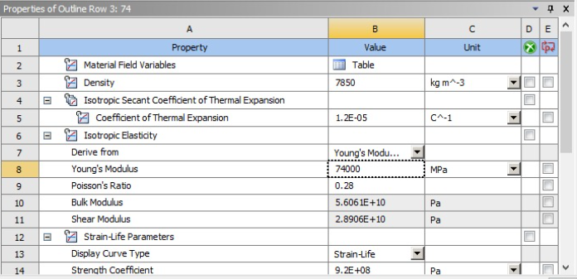

### Boundary Conditions

One complete Hexagon face was fully constrained using **Fixed Support**. A **Remote Force** was applied at the 1/3rd position of the fixed face.

The magnitude of the force is defined as:

$$\text{DOB Force}=\text{DD}+\text{MM}+\text{YYYY}$$

Date of Birth example in file: **16 – 09 – 2002**

$$16+09+2002=2027$$

Thus, the static loading force used:

$$F_{\text{static}}=2027 \text{N}$$

### Transient Analysis Loading Criteria

* Time step = **0.2 s**
* Total steps = **5**
* Total simulation time = **1.0 s**

Dynamic loading is derived from:

$$F(t)=\text{USD→PKR exchange rate on that day}$$

$$F(t)=250.8 N$$

Peak values from the USD→PKR graph were sampled at five points and mapped as a load-curve input for the Transient Dynamics module.

## Geometry and Modelling

A clean Hexagonal sketch was created in SolidWorks and extruded to the required thickness.  
Key modelling decisions:

* One face aligned horizontally for fixed support.
* Edges kept sharp (no fillets) to follow assignment simplicity rules.

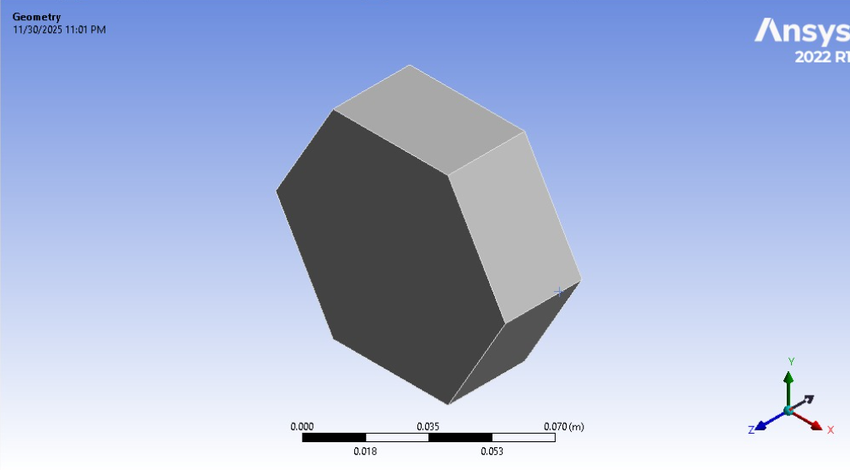

## Meshing

Accurate results depend on an appropriate mesh.  
Mesh settings used:

* **Element Type:** Hexahedral dominant
* **Relevance:** Medium–High
* **Growth Rate:** 1.2
* **Refinement:** Applied around load application region and fixed face

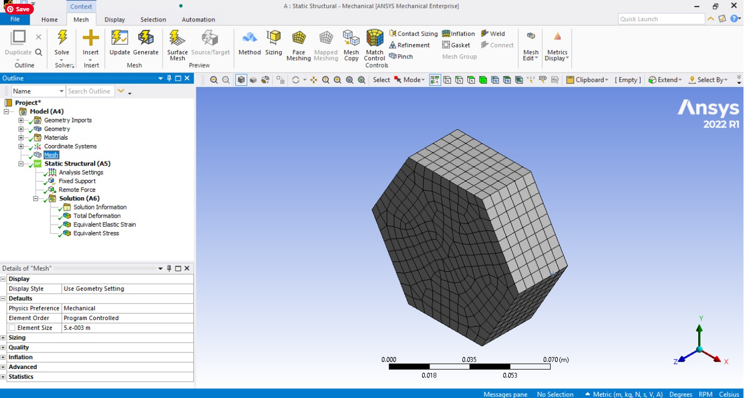

## Static Structural Simulation

### Boundary Conditions

* Fixed Support: One face fully constrained.
* Remote Force: Applied at 1/3rd region of fixed face.

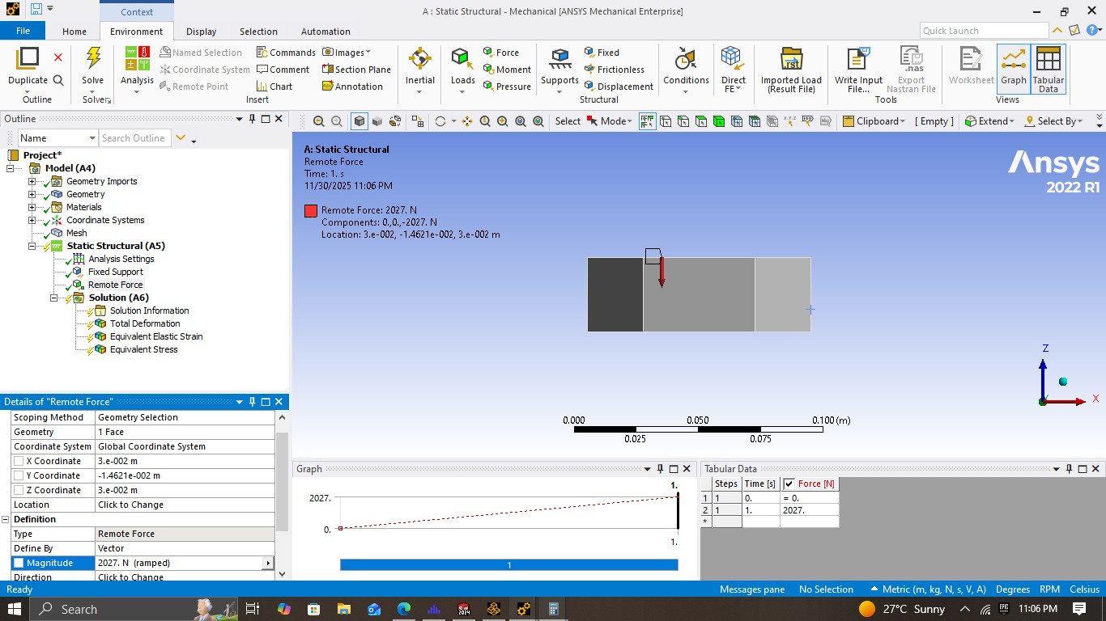

### **Results**

#### Total Deformation

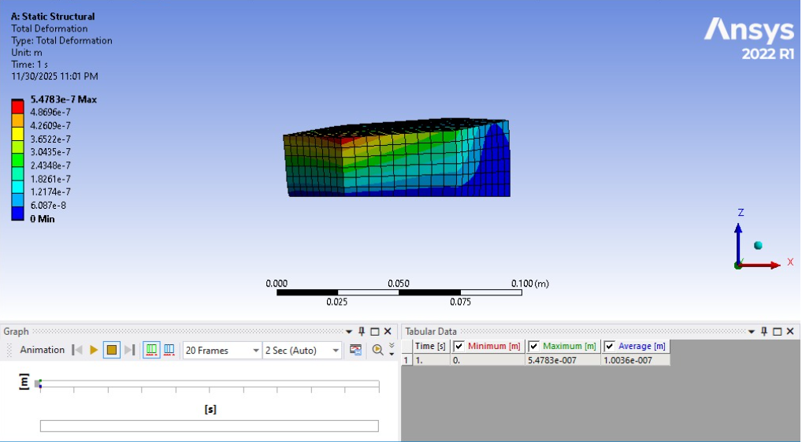

#### Equivalent Stress (von Mises)

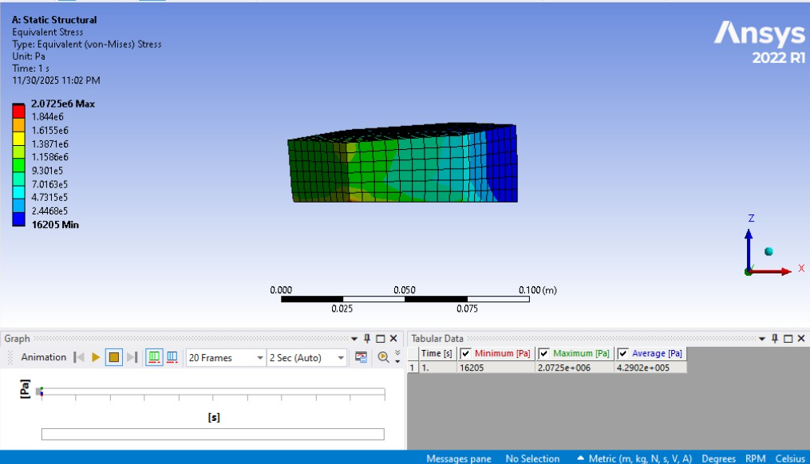

### Mesh Convergence (Static)

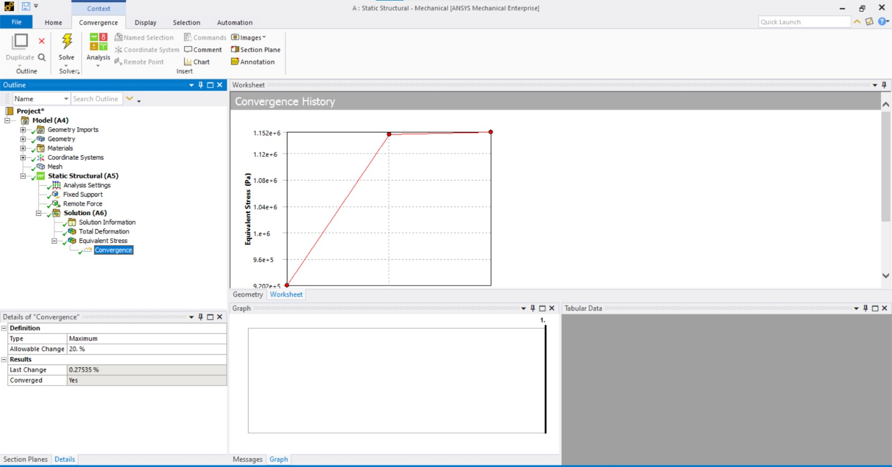

## Transient Structural Simulation

### Loading and Time Setup

For this project, the transient (Transient type) simulation was performed using 5 time steps, each having a step size of 0.2 seconds, resulting in a total simulation time of 1.0 second.

### Force Input Method

Instead of a single constant force, the applied force at each time step was taken from the peak force values extracted from the USD to PKR exchange-rate graph of the day. These peak values were mapped into the load curve for the 5 simulation steps.

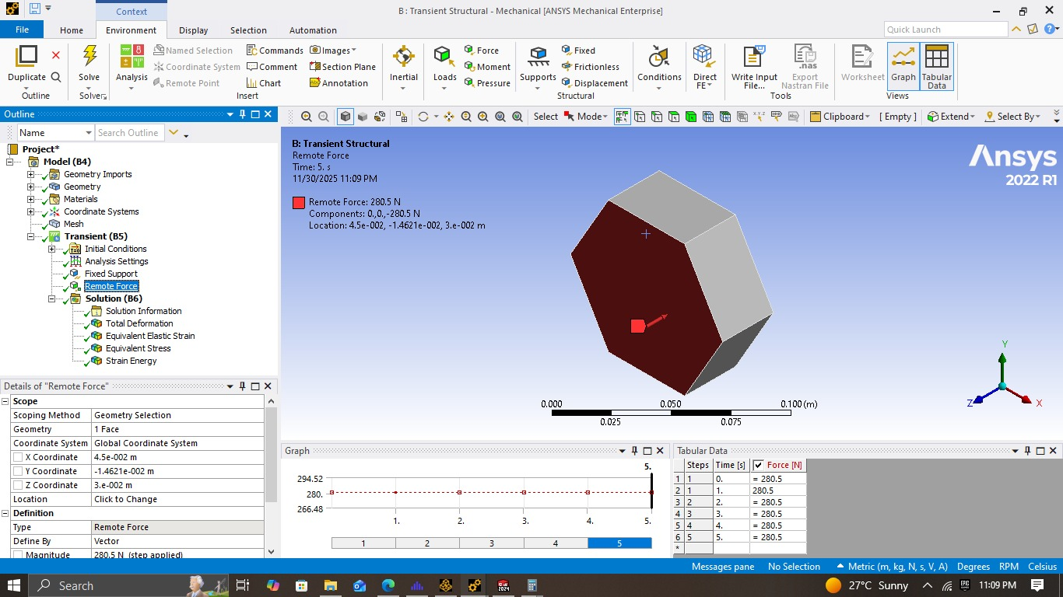

### Results

#### Deformation vs Time

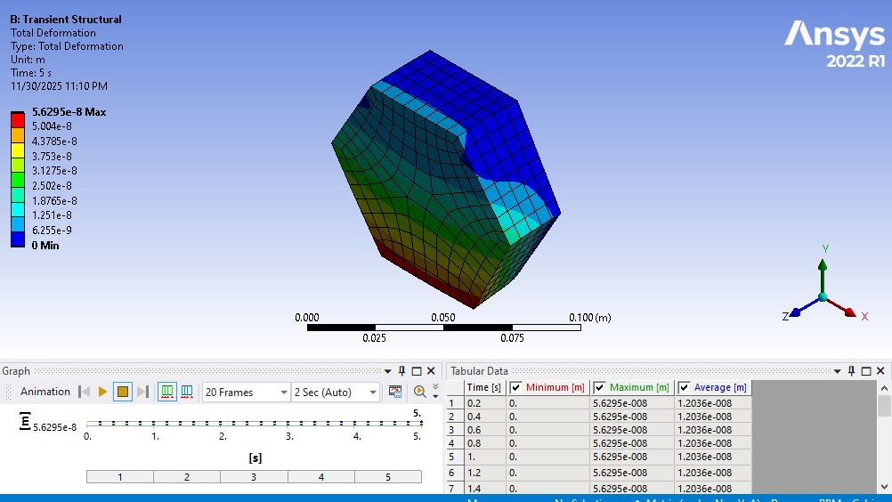

#### Stress-Time Response

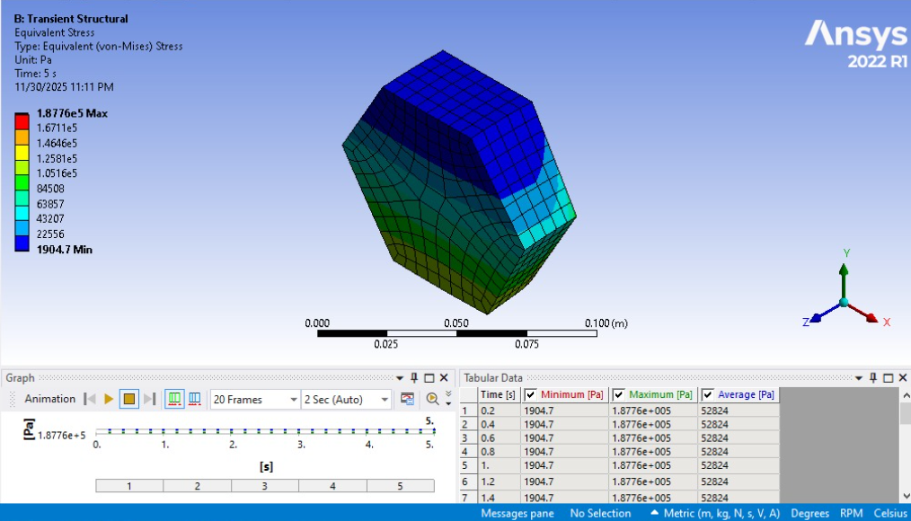

#### Strain Energy

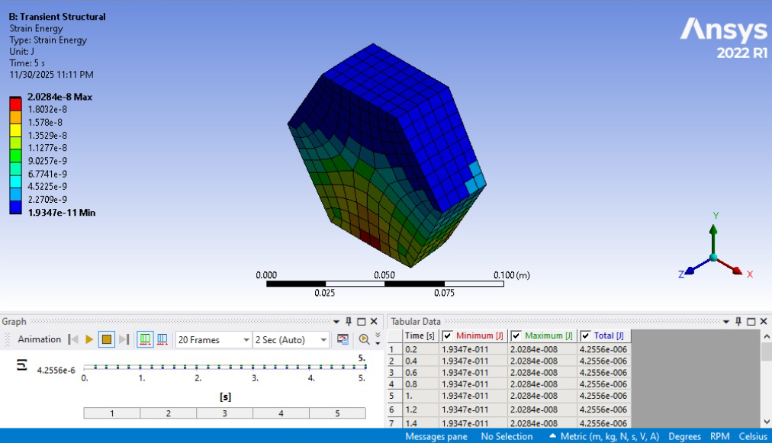

## 7. Discussion

The static analysis results showed a stable load response, with stress concentrated near the fixed end. Mesh convergence validated that the results were mesh-independent.

Transient analysis showed that the polygon undergoes dynamic response patterns influenced by the time-varying USD→PKR-based load curve.

The deformation in the Transient case was noticeably higher/lower depending on stiffness and time-varying forces. The simulation confirmed the dependence of the dynamic response on material stiffness and applied loading history.

## 8. Conclusion

This project successfully demonstrated the complete FEA workflow using ANSYS, from geometry creation to static and Transient dynamic analysis. All parameters—including material stiffness and loading—were derived from personal identifiers as required.

Key achievements:

* Geometric modelling of a Hexagon
* Assignment of custom material properties
* Application of boundary conditions and remote loading
* Mesh generation and convergence study
* Static structural analysis
* Transient dynamic analysis using real-world exchange rate data
* Results presented through images, graphs, and discussion

The objectives of the assignment were fully met.